

Practices for Secure Software Report

Table of Contents
Practices for Secure Software Report 1
Document Revision History 3
Client 3
Developer 4
1. Algorithm Cipher 4
2. Certificate Generation 4
3. Deploy Cipher 5
4. Secure Communications 5
5. Secondary Testing 6
6. Functional Testing 6
7. Summary 6
8. Industry Standard Best Practices 7

Document Revision History

Version | Date | Author | Comments
1.0 | August 16, 2026 | Bryan Deacy

Client



Developer
Bryan Deacy

Algorithm Cipher
Artemis Financial's application needs two different types of cryptography working side by side, not one cipher trying to do everything. For securing the connection between the browser and the server, this report recommends AES-256 for the actual data encryption, paired with RSA or ECDHE for the key exchange that happens during the TLS handshake. For verifying that data has not been altered in transit, this report recommends SHA-256 as the hashing algorithm, which is exactly what was implemented in the refactored checksum endpoint.
Hash Functions and Bit Levels: A hash function takes an input of any size, whether that is one character or an entire file, and produces a fixed-length output called a digest. SHA-256 produces a 256-bit digest, which comes out to 64 hexadecimal characters, no matter how large or small the original input was. Change even one character in the input and the entire digest comes out completely different, a property known as the avalanche effect. This makes SHA-256 useful for checksums: if the digest calculated on the receiving end matches the digest calculated on the sending end, the data arrived intact. SHA-256 belongs to the SHA-2 family, which replaced the older SHA-1 algorithm after researchers demonstrated practical collision attacks against it, meaning two different inputs could produce the same digest. A 256-bit output space makes that kind of collision computationally infeasible with current technology.
Random Numbers and Key Types: Strong encryption depends on unpredictable randomness. TLS handshakes, key generation, and initialization vectors all rely on a cryptographically secure pseudo random number generator, not the kind of random number function used in a game or a simple script. If an attacker can predict the random values a system generates, the encryption built on top of them falls apart no matter how strong the cipher itself is. Symmetric encryption, like AES, uses the same key for both encrypting and decrypting data. It is fast and efficient, which is why it handles the bulk of the actual data transfer once a secure session is established. Asymmetric encryption, like RSA, uses a key pair instead: a public key that anyone can use to encrypt data, and a private key that only the server holds to decrypt it. Asymmetric encryption is slower, so TLS uses it during the handshake to securely exchange a symmetric session key, then switches to the faster symmetric cipher for everything after that.
History and Current State: Encryption has come a long way from simple substitution ciphers. The Data Encryption Standard, or DES, was the U.S. government standard through the 1970s and 1990s, but its 56-bit key length became too short to withstand modern brute-force attacks. The Advanced Encryption Standard, AES, replaced it in 2001 and remains the current standard, with AES-256 considered secure against any known practical attack. On the hashing side, MD5 and SHA-1 were once considered adequate but have both been broken by researchers and are no longer recommended for security-sensitive applications. SHA-256 and the rest of the SHA-2 family are the current standard, and SHA-3 is available for applications that need an alternative construction. Looking further ahead, the security industry is already researching post-quantum cryptography, since a sufficiently powerful quantum computer could eventually break RSA and similar algorithms that depend on the difficulty of factoring large numbers.

Certificate Generation
A self-signed certificate was generated using Java Keytool and exported as a CER file. This certificate supports the HTTPS configuration used by the local Spring Boot server. Because this is a development environment, the browser does not trust the certificate by default, but the certificate still allows the application to demonstrate encrypted HTTPS communication.
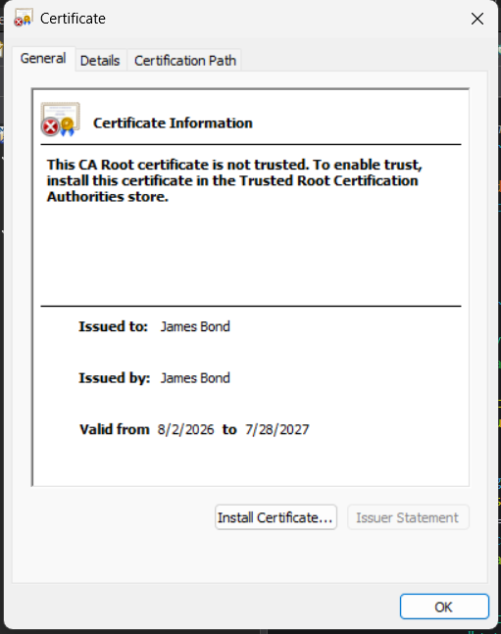

Deploy Cipher
The application was refactored to deploy a SHA-256 cryptographic hash function through the /hash endpoint. The endpoint uses Java’s MessageDigest class to hash a unique data string containing my name and returns the original data, the algorithm used, and the checksum value. The screenshot confirms that the checksum verification functionality works.
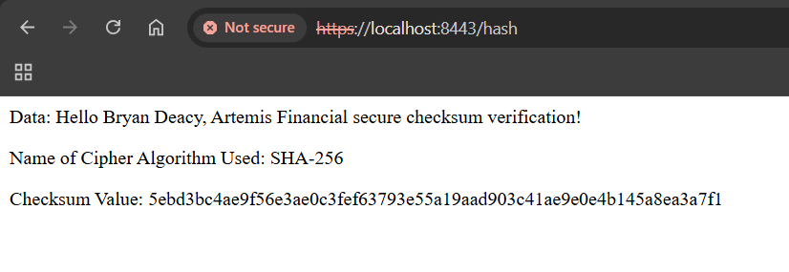

Secure Communications
The application.properties file was updated to run the application over HTTPS on port 8443. The configuration points to the self-signed keystore and enables SSL for the Spring Boot application. The browser screenshot confirms that the refactored endpoint is being accessed through https://localhost:8443/hash.


Secondary Testing
After refactoring the application, I ran OWASP Dependency-Check through Maven to perform secondary static testing. The scan completed successfully with Dependency-Check version 12.2.2 and reviewed 49 dependencies, including 28 unique dependencies. The report identified 213 known vulnerabilities, but these findings are tied to the existing project dependencies rather than to the SHA-256 checksum code added during the refactor.
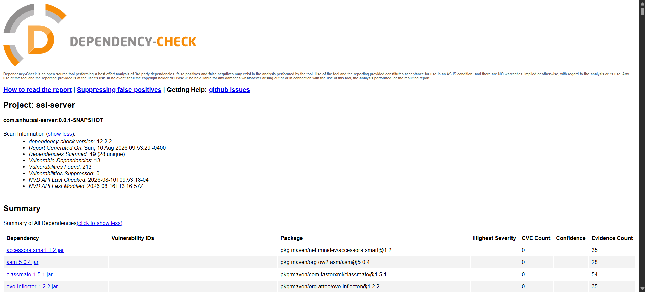

Functional Testing
Functional testing confirmed that the refactored Spring Boot application compiled and executed without errors. The console output shows that Apache Tomcat started successfully on HTTPS port 8443 and that SslServerApplication started successfully. The working /hash endpoint further confirms that the checksum route, HTTPS configuration, and keystore setup are functioning together. As part of the manual review, I checked the refactored /hash endpoint for syntax errors, logical flow, and security concerns. The endpoint correctly creates a SHA-256 MessageDigest object, hashes the unique data string, converts the result to hexadecimal output, and returns the data, algorithm name, and checksum to the browser. One cleanup item before production would be replacing printStackTrace() in the exception handler with a proper application logger so errors are handled consistently without exposing unnecessary implementation details.
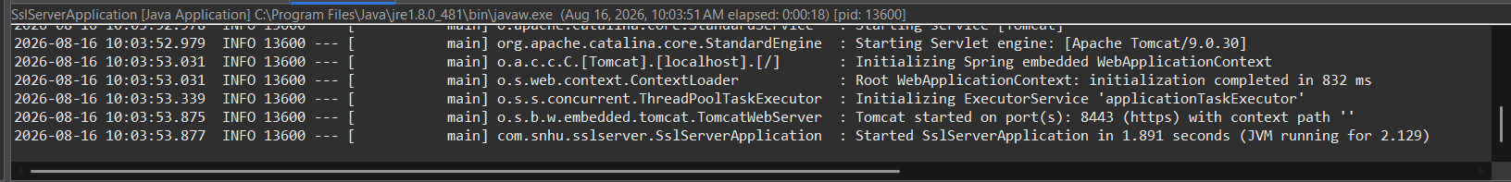

Summary
The vulnerability assessment process flow diagram provided for this project breaks security work into a handful of stages: identifying weaknesses, assessing their severity, remediating the code, and verifying that the fix actually holds up under testing. This project touched all four stages, but the heaviest lifting happened in the remediation and verification steps.
On the remediation side, three layers of security were added to Artemis Financial's application in this refactor. First, a SHA-256 checksum endpoint gives the application a way to verify that transmitted data has not been tampered with or corrupted in transit, addressing the data integrity gap identified in the Project One assessment. Second, the application properties file now enforces HTTPS instead of plain HTTP, encrypting traffic between the client and server so financial data cannot be read or intercepted on an unsecured network. Third, a self-signed certificate was generated through Java Keytool to support the TLS handshake, giving the server something to authenticate itself with even in this development environment.
On the verification side, a second dependency-check scan ran against the refactored code base to confirm that none of the new code introduced fresh vulnerabilities. That scan flagged 213 known vulnerabilities across 13 dependencies, but every one of them traced back to the underlying Spring Boot 2.2.4 framework and its bundled libraries, such as Tomcat, Spring Core, and SnakeYAML, not to the checksum endpoint or the HTTPS configuration added during this project. That distinction matters. It confirms the code written for this assignment does not introduce new attack surface, while also surfacing a legitimate follow-up recommendation: Artemis Financial should plan an upgrade to a current, supported Spring Boot version to resolve the framework-level vulnerabilities that a code-level refactor cannot fix on its own.

Industry Standard Best Practices
Several established security practices guided the decisions made in this project. The checksum implementation follows NIST and OWASP guidance to use SHA-2 family algorithms instead of the deprecated MD5 or SHA-1, both of which have documented collision vulnerabilities that make them unsuitable for anything security-related. The HTTPS configuration follows the same logic: modern TLS protocols instead of older SSL versions, which have known weaknesses that have been publicly documented for years. Running a static dependency scan as part of the build process, rather than as an afterthought, follows the OWASP recommendation to treat software composition analysis as a routine part of the development pipeline instead of a one-time check before release.
These practices matter beyond just meeting a rubric. Artemis Financial handles retirement savings, investment portfolios, and insurance information for its clients, the kind of data that carries real financial and legal consequences if it is exposed. A single unpatched vulnerability or a weak hashing algorithm can be the difference between a routine audit and a data breach that ends up in the news. Following recognized standards instead of improvising security measures also gives Global Rain something concrete to point to when Artemis Financial or its regulators ask how client data is protected. This is not just about writing secure code for one project, it is about building a repeatable, documented process that keeps security consistent as the application grows and as new developers join the team. That consistency is what "security is everyone's responsibility" means in practice: it only works if the standards are clear enough for everyone to follow.

